|  |  |  |  |
| --- | --- | --- | --- |
| \\lyng-dc1\StaffShared\Learning Bugs Animals ALL subjects\characters bugs animals\Cyril the Snail - History.jpeg**Lyng Primary School Knowledge Organiser** | | | |
| **History Topic:** | **Bostin’ Black Country**  **How was the life of a Victorian child similar and different to our lives now?** | Year 2 | Spring |

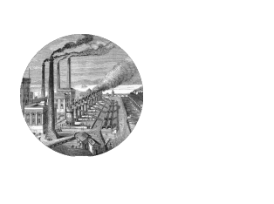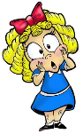

**Background information for parents and teachers**

The Black Country is an area of the West Midlands covering most of the four boroughs of Dudley, Sandwell, Walsall and Wolverhampton. During the industrial revolution, it became one of the most industrialised parts of the UK. The first trace of the phrase “The Black Country” as an expression dates from the 1840’s. This period in time is known as the Victorian era due to the reigning monarch Queen Victoria. Queen Victoria is the second longest reigning monarch of the UK and was affectionately known as the grandmother of Europe as many of her children married into other European monarchies. Life for children in the Victorian times was very different to life today.

|  |  |
| --- | --- |
| **What Step On and Goldilocks words will I use?** | |
| **Spelling** | **Definition** |
| Industrial Revolution | The change of replacing hand tools with machinery. |
| Monarch | The king or queen who reigns over a country. |
| Chronological | Events in the order that they occurred. |
| Vicrorian | Relating to Queen Victoria |
| Era | A long and distinct piece of history. |
| Decade | Ten Years |
| Century | Hundred years |

|  |  |
| --- | --- |
| **When? (Timeline of key events)** | |
| 1819 | Alexandrina Victoria is born as a royal princess. |
| 1837 | Queen Victoria takes the crown at the age of 18. |
| 1838 | The first modern railroad line opens. |
| 1840 | Charles Dicken publishes ‘A Christmas Carol’. |
| 1851 | The Great Exhibition opens in London. |
| 1876 | The first telephone call is made. |
| 1880 | The Elementary Act of 1880 makes school attendance mandatory for all children. |
| 1901 | Queen Victori dies. |
| 1970’s | The Black Country Living Museum opened. |

“It was the best of times, it was the worst of times, it was the age of wisdom, it was the age of foolishness, it was the epoch of belief, it was the epoch of incredulity, it was the season of Light, it was the season of Darkness, it was the spring of hope, it was the winter of despair.”

– Charles Dickens (1812-1870), *A Tale of Two Cities*

**Great Quotes**

**Hook (LOtC)**

Reinacting life in a Victorian classroom.

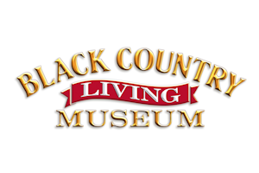

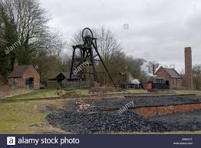

**TRIP/VISITOR**

Trip to Black Country Living Museum. .

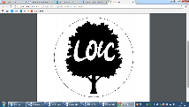

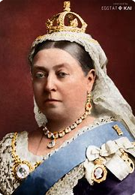

**Key Facts and Famous Figures**

* Queen Victoria was **Queen of the United Kingdom of Great Britain and Ireland** for 63 years.
* Queen Victoria married Prince Albert from Germany.
* The queen's reign is known as the **Victorian age**.
* Queen Victoria was only 18 when she became **Queen**.
* At the start of Queen Victoria’s reign, many **children** had to **work**. By the time the queen died, more children were able to go to **school**.
* When Victoria became Queen in 1837, most people travelled by horse or on foot. The Railway Age began during the queen's reign.
* **Prince Albert** died when he was 42. Queen Victoria was extremely **upset**. The queen was so sad that she dressed in **black clothes** for the rest of her life.
* Victoria and Albert had **nine children**.

**Key Questions – sequence of learning**

* What key events happened in Queen Victoria’s life?
* What were Victorian schools like?
* What was life like for rich and poor Victorian children?
* What jobs did Victorian children do?
* Are toys the same in Victorian times as they are today?

**Agreed Outcome**

* Non chronological report on Queen Victoria
* Comparioson of Victorian schools and toys
* Comparison of children in Victorian times and today.

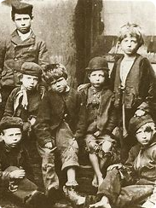

|  |  |  |  |
| --- | --- | --- | --- |
| \\lyng-dc1\StaffShared\Learning Bugs Animals ALL subjects\characters bugs animals\Cyril the Snail - History.jpeg**Lyng Primary School Knowledge Quiz** | | | |
| **History Topic:** | **Bostin’ Black Country** | Year 2 | Spring |

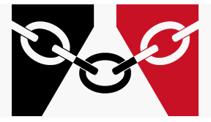

|  |  |  |
| --- | --- | --- |
| 6. How many children did Queen Victoria have? | **S** | **E** |
| 1 |  |  |
| 9 |  |  |
| 1 |  |  |

|  |  |  |
| --- | --- | --- |
| 7. Who helped the rights of children? | **S** | **E** |
| The Prime Minister |  |  |
| The King |  |  |
| Lord shafesbury |  |  |

|  |  |  |
| --- | --- | --- |
| 1. Name a toy that children would have in Victorian times. | **S** | **E** |
|  |  |  |

|  |  |  |
| --- | --- | --- |
| 1. Schools became free to go to in: | **S** | **E** |
| 2020 |  |  |
| 1890 |  |  |
| 1980 |  |  |

|  |  |  |
| --- | --- | --- |
| 1. What lessons did children have in Victorian schools? | **S** | **E** |
| Science, History, Geography |  |  |
| Reading, Writing, Arithmetic |  |  |
| Art, PE and D&T |  |  |

|  |  |  |
| --- | --- | --- |
| 1. The monarch during the Industrial Revolution was: | **S** | **E** |
| Queen Elizabeth 2nd |  |  |
| King Charles |  |  |
| Queen Victoria |  |  |

**Our Bostin’ Black Country**

**Quick Quiz**

|  |  |  |
| --- | --- | --- |
| 1. When did the Industrial revolution begin? | **S** | **E** |
| 1760’s |  |  |
| 1860’s |  |  |
| 1960’s |  |  |

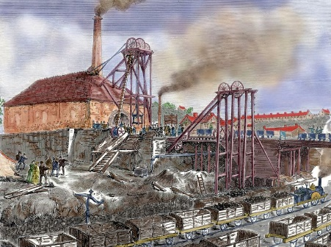

|  |  |  |
| --- | --- | --- |
| 1. Name an object that was in a Victorian school. | **S** | **E** |
|  |  |  |

|  |  |  |
| --- | --- | --- |
| 1. What jobs did Victorian children NOT do? | **S** | **E** |
| Cooking |  |  |
| Chimney sweeping |  |  |
| Coal mine |  |  |

|  |  |  |
| --- | --- | --- |
| 1. In schools in the Victorian times, children were hit with the cane | **S** | **E** |
| True |  |  |
| False |  |  |